**Selected Problems - Chapter 10**

**1.2**

| Workers | Total Pounds  of Macadamia Nuts Per  Week | *MP* | *MRP* |
| --- | --- | --- | --- |
| 0 | 0 | --- | --- |
| 1 | 1,200 | 1,200 | $4,200 |
| 2 | 2,000 | 800 | $2,800 |
| 3 | 2,500 | 500 | $1,750 |
| 4 | 2,700 | 200 | $700 |
| 5 | 2,800 | 100 | $350 |
| 6 | 2,400 | −400 | −1,400 |

The firm should hire workers as long as *MRP > W*. When *W* = $800, the firm should hire three workers. If *W* doubles to $1,600, the firm should still hire three workers because the *MRP* of the third worker ($1,750) is still greater than the cost of hiring him or her ($1,600).

**4.1** (a) Process 1 costs $25 per gizmo, Process 2 costs $24, and Process 3 costs $33. Process 2 is cheapest.

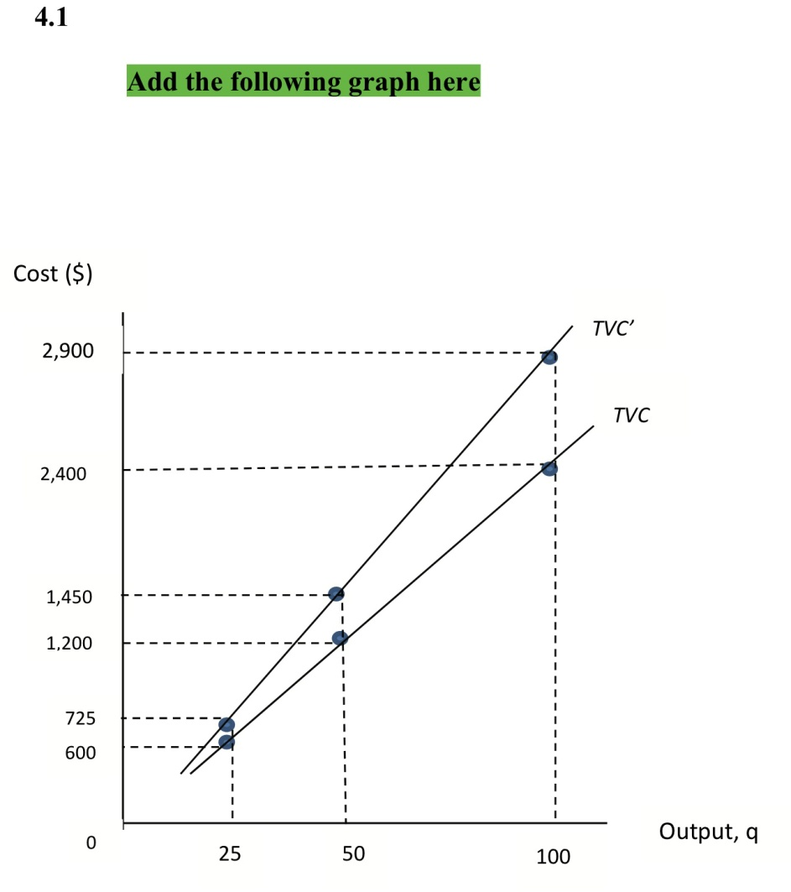

(b, c) When *q =* 25, *K* = 75 and *L* = 75, *TVC* = $600.

When *q =* 50, *K* = 150 and *L* = 150, *TVC* = $1,200.

When *q =* 100, *K* = 300 and *L*= 300, *TVC* = $2,400.

(d) If capital costs $7 and labor costs $3 per unit, process 1 becomes cheapest, with a cost of $29 per gizmo.

When *q =* 25, *K* = 50 and *L* = 125, *TVC* = $725.

When *q =* 50, *K* = 100 and *L*= 250, *TVC* = $1,450.